Carlos Durana, Ph.D., M.Ac.
4915 St. Elmo Ave., Suite 504 - Room 7C  Bethesda, MD 20814  301-654-0800 | 2265 Cedar Cove Court  Reston, VA 20191  703-408-4965  703-620-0420 (FAX)
PROBLEM DIAGNOSIS QUESTIONNAIRE
When did things in the relationship begin to change towards the worst? What was happening then in your family (internal and external stressors)? What contributed to the change?
What maintains the relationship the way it is? What is your contribution to that?
What keeps you in the relationship? If you could leave without financial hardships or other repercussions, would you leave?
How do you want the relationship to be? What is your vision of it? What are your hopes, wishes and dreams?
What is the problem? What is the tissue underneath the problem? (See page title “Basis issues underlying relationship problems.”)
What would you like to change? What might it look and feel like when the relationship improves?
How did the problem develop?
How is the problem maintained? What is your role or contribution?These are the things that you repeat and feel like you are beating your head against the wall?
What is your partner’s role in the problem?
What are your assets, strengths and resources? Your partner’s?
What are the exceptions to the problem?
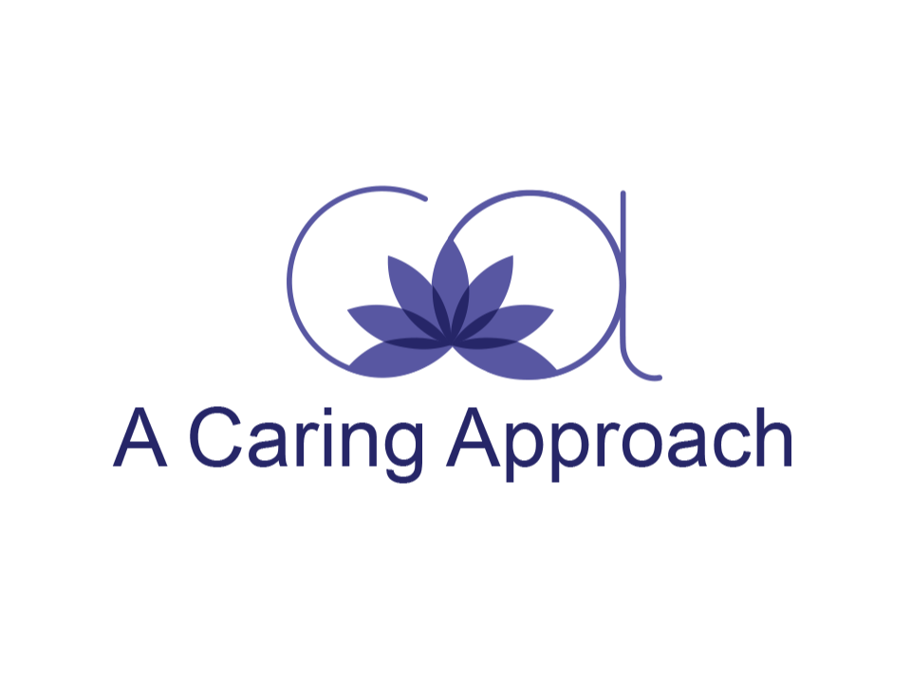
When things work well and you are getting along, what do you contribute towards that? Your partner’s contributions then?
What is one thing you could do to improve the situation? One thing your partner could do?
Do more of what works and less of what hasn’t worked.List Behavioral Goals: Actions speak louder than words.
Offering Couples Therapy, Couples Counseling, Marriage Counseling and Marriage Therapy in Reston, VA. and Bethesda, MD.

