Carlos Durana, Ph.D., M.Ac.
4915 St. Elmo Ave., Suite 504 - Room 7C  Bethesda, MD 20814  301-654-0800 | 2265 Cedar Cove Court  Reston, VA 20191  703-408-4965  703-620-0420 (FAX)
PROBLEM DIAGNOSIS QUESTIONNAIRE (INDIVIDUAL)
What is the issue or the problem? What are the issues underneath the problem?
How did the problem develop?
When did things begin to change for the worse? What was happening then in your family (internal and external stressors)? What contributed to the change?
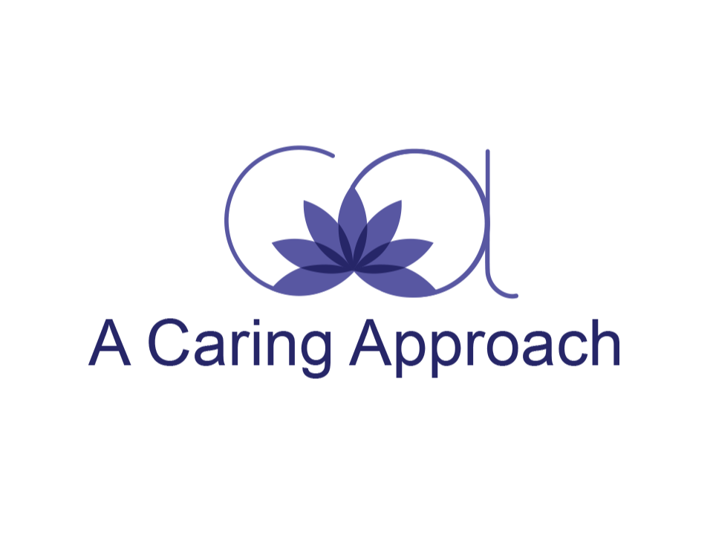
How is the problem maintained? What is your role or contribution – the things that you repeat and make you feel like you are beating your head against the wall?
How do you want things to be? What is your vision of it? What are your hopes, wishes, and dreams?
What would you like to change? What might it look and feel like when things improve?
If you have a partner, what is her/his role in the problem?
What are your assets, strengths, and resources?
When things work well, what do you do to contribute towards that?
What is one thing you could do to improve the situation?

Dr. Carlos Durana offers Individual Counseling and Psychotherapy, Couples Therapy, Couples Counseling, Marriage Counseling, and Marriage Therapy in Reston, VA and Bethesda, MD.

