Carlos Durana, Ph.D., M.Ac.
4915 St. Elmo Ave., Suite 504 - Room 7C  Bethesda, MD 20814  301-654-0800 | 2265 Cedar Cove Court  Reston, VA 20191  703-408-4965  703-620-0420 (FAX)
PATIENT COVID QUESTIONNAIRE
Dear Patients,
This document contains important information about in-person services in light of the public health crisis.
Your Responsibility to Minimize Your Exposure:
To obtain services in person, you agree to take certain precautions which will help keep everyone (you, me, and our families, and other patients) safer from exposure, and sickness.
Circle your answer to the following:
*You will keep your appointment only if symptom free. Do you have any of the following?
(Fever, Cough, Shortness of Breath, Flu-like symptoms etc.) Yes or No

*Have you had contact with any confirmed COVID-19 positive people? Yes or No

*Have you traveled to any foreign country? Yes or No
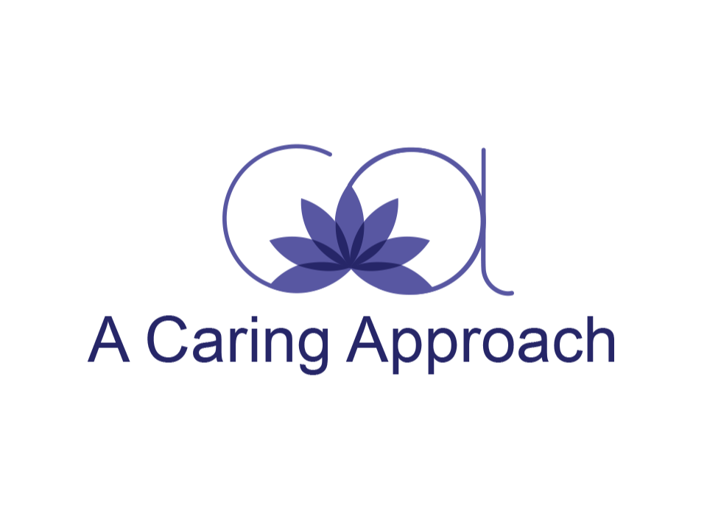
*Have you traveled domestically? Yes or No
In addition, please initial that you are in agreement with the following:
You will wash your hands or use hand sanitizer when you enter the building. ___
You will keep a distance of 6 feet and there will be no physical contact (e.g. no shaking hands) with me. _____
You will take responsible steps between appointments to minimize your exposure. ____
If you have a job that exposes you to those who are infected, you will let me know. ____
If you show up for your appointment and I feel that you are showing symptoms, you will be asked to reschedule. ____
I may change the above precautions if additional local, state, or federal orders or guidelines are published. If that happens, we will talk about any necessary changes.
My Commitment to Minimize Exposure:
My practice has taken steps to reduce the risk of spreading the virus within the office. Please let me know if you have questions about these efforts. These include the wearing of masks by both myself and my patient. Masks will be provided if needed. If you arrive by car, please wait in your car until I call you. Appointments will be staggered to ensure limited exposure to others.
Your Confidentiality in the Case of Infection:
If you have tested positive for the coronavirus, I may be required to notify local health authorities that you have been in the office. If I have to report this, I will only provide the minimum information necessary for their data collection and will not go into any details of the reason(s) for our visits. By signing this form, you are agreeing that I may do so without an additional signed release.
Informed Consent:
This agreement supplements the general informed consent/business agreement that we agreed to at the start of our work together.

Your signature below shows that you agree to these terms and conditions.

_________________________ _________________________
Patient/Client Date

_________________________ _________________________
Therapist Date

