Carlos Durana, Ph.D., M.Ac.
4915 St. Elmo Ave., Suite 504 - Room 7C  Bethesda, MD 20814  301-654-0800 | 2265 Cedar Cove Court  Reston, VA 20191  703-408-4965  703-620-0420 (FAX)
LIFE HISTORY QUESTIONNAIRE
Purpose:
The purpose of this questionnaire is to get a complete picture of your life history and family background. In therapy, we are concerned with issues that impact on you, your relationships, and your family from many sources. Among those sources are (a) your family of origin, that is your parents and grandparents; (b) your physical health; (c) your life history; and (d) things that are influencing you right now. By asking you about these things in questionnaire form, we can save a great deal of valuable therapy interview time. Therefore, answering these routine questions as fully and as accurately as you can will make it possible for us to get to work on the things that concern you much more quickly.
All case records are strictly confidential. NO OUTSIDER IS PERMITTED TO SEE YOUR CASE RECORD WITHOUT YOUR PERMISSION IN WRITING.
If you have any questions about this questionnaire, please feel free to ask at any time. If you do not wish to answer a question, you may write “I do not wish to answer.”
How did you hear about Dr. Durana? (circle those that apply)
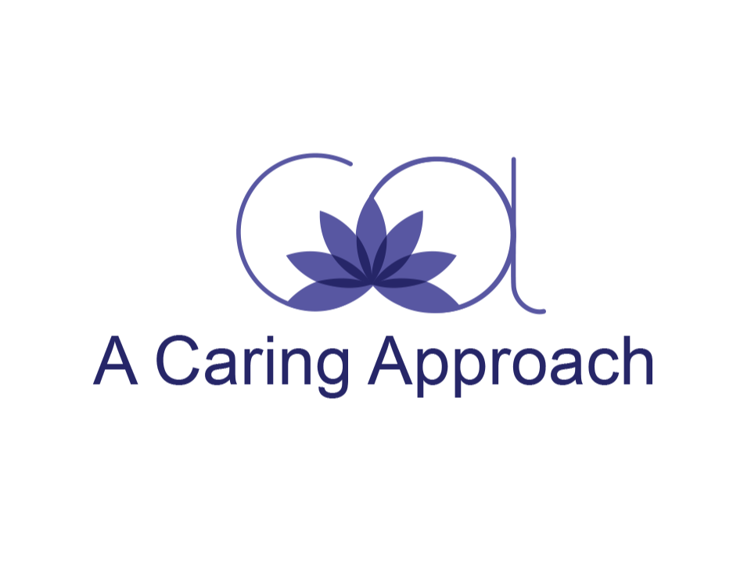
Referral Web Google Listing Other

DATE____________________________

General Information:
Name: ___________________________________________________ Age: _____________
Partner’s Name: ___________________________________________ Age: _____________
Children’s Names: ___________________________________ Sex: ______ Age: _________
____________________________________ Sex: ______ Age: ______________
____________________________________ Sex: ______ Age: ______________
____________________________________ Sex: ______ Age: ______________

Address: ______________________________________________________________________________
______________________________________________________________________________
Telephone Numbers: (days) _____________________ (evenings) ________________________
Email address: _______________________________________________________________________
Your Occupation: ________________________________
Partner’s Occupation: _____________________________
Current Relationship Status (check one)
□ Single □ Engaged □ Married □ Separated □ Divorced □Widowed
Remarried: □ Yes □ No How many times? ___________________________
What is/are the issue(s) or problem(s)? Please describe: __________________________________________________________________________________________________________________________________________________________________________________________________________________________________________________________________________________________________________________________________________________________________________________________________________________________________________________________________________________________________________________________________________________________________________________________________________________________________________________________________________________________________________________________________________________________________________________________________________________________________________________________________________________________
On the scale below, please indicate how upsetting your problem(s) is/are right now:
mildly upsetting _____ moderately upsetting _____ very upsetting _____
extremely upsetting _____ totally upsetting _____

When did your problem(s) begin (describe and give dates)? ________________________________________________________________________________________________________________________________________________________________________________________________________________________________________________________________________________________________________________________
Please describe any important event occurring at that time or since then that may have started the problem(s) or which keep them going: __________________________________________________________________________________________________________________________________________________________________________________________________________________________________________________________________________________________________________________________________________________________________________________________________________________________________________________________________________________________________________________________________________________________________
What do you believe causes or contributes to the maintenance of your problem(s), for example, stresses, emotional reactions, diet, etc.? ________________________________________________________________________________________________________________________________________________________________________________________________________________________________________________________________________________________________________________________
What solutions to your problems have you found helpful? ______________________________________________________________________________________________________________________________________________________________________________________________________________________________________________________________________________________________________________________________________________________________________________________________________

Have you received any prior professional assistance for your problem? If so, give name(s), professional title(s), date(s) of treatment(s), and results: ________________________________________________________________________________________________________________________________________________________________________________________________________________________________________________________________________________________________________________________
Family of Origin History:
Date of Birth: ___________________ Place of Birth: _________________________________
Siblings:
Number of brothers: _________________
Brothers’ ages: _____________________
Number of sisters: __________________
Sisters’ ages: _______________________

Father: Living? __________________ If alive, give father’s age: _______
Deceased? ______________ If deceased, give father’s age at time of death: _______
How old were you at the time? _______ Cause of death: ___________________
Occupation: ______________________
Health: _______________________________________________________________________
Does or did your father have (check all that apply):
⃞ Drinking problem
⃞ Drug problem
⃞ Depression
⃞ Depression with highs and lows
⃞ Mental Illness

Mother: Living? __________________ If alive, give mother’s age: _______
Deceased? ______________ If deceased, give mother’s age at time of death: _______
How old were you at the time? _______ Cause of death: ___________________
Occupation: ______________________
Health: _______________________________________________________________________
Does or did your mother have (check all that apply):
⃞ Drinking problem
⃞ Drug problem
⃞ Depression
⃞ Depression with highs and lows
⃞ Mental Illness

Did or does any other member of your family have problems with (check all that apply):
⃞ Drugs ⃞ Alcohol ⃞ Depression
⃞ Diabetes ⃞ Mental Illness ⃞ Epilepsy
If so, state who: __________________________________________________________

Your religion: As a child: _____________________ As an adult: ___________________
Your education: What is the last grade completed? _________________________________
Do you have a degree? Please list: ______________________________________________

Check any of the following that applied during your childhood or adolescence:
⃞ Happy Childhood ⃞ Unhappy Childhood
⃞ Emotional Problems ⃞ Drug Abuse
⃞ Eating Disorder ⃞ School Problems
⃞ Family Problems ⃞ Behavior Problems
⃞ Physical Abuse ⃞ Medical Problems
⃞ Alcohol Abuse ⃞ Sexual Abuse
⃞ Legal Trouble ⃞ Other Problems: __________________________________________

If you were not brought up by your parents, who raised you and between what years? ______________________________________________________________________________
Give a description of your father’s (or father substitute’s) personality and his methods of discipline (past and present): __________________________________________________________________________________________________________________________________________________________________________________________________________________________________________
How did your father show affection, and how often did he share affection with you? With others in the family? (past and present): ________________________________________________________________________________________________________________________________________________________________________________________________________________________________________________________________________________________________________________________
Give a description of your mother’s (or mother substitute’s) personality and her methods of discipline (past and present):
__________________________________________________________________________________________________________________________________________________________________________________________________________________________________________
How did your mother show affection, and how often did she share affection with you? With others in the family? (past and present): ________________________________________________________________________________________________________________________________________________________________________________________________________________________________________________________________________________________________________________________
What specific methods did your father (or father substitute) use to control you and other members of the family? __________________________________________________________________________________________________________________________________________________________________________________________________________________________________________
What specific methods did your mother (or mother substitute) use to control you and other members of the family? __________________________________________________________________________________________________________________________________________________________________________________________________________________________________________
What did your father do to control the expression of affection in the family? __________________________________________________________________________________________________________________________________________________________________________________________________________________________________________
What did your mother do to control the expression of affection in the family? __________________________________________________________________________________________________________________________________________________________________________________________________________________________________________
What were the prevailing emotional overtones in your family when you were growing up? __________________________________________________________________________________________________________________________________________________________________________________________________________________________________________
Has any relative attempted or committed suicide?
⃞ Yes ⃞ No
Has any relative had serious problems with the law?
⃞ Yes ⃞ No

Your Personal History:
What is your height? _______ ft. ______ inches
What is your weight? _______________ pounds
Do you now have or have you ever had (check all that apply):
⃞ High blood pressure ⃞ Epilepsy
⃞ Alcohol problems ⃞ Drug problems
⃞ Unusual physical problems
⃞ Strange or unusual sensations
Other Illnesses: __________________________________________________________________________________________________________________________________________________________________________________________________________________________________________
Have you ever been hospitalized for psychological problems? ⃞ Yes ⃞ No
If Yes, when and where? ______________________________________________________________________________
Do you have a family physician? ⃞ Yes ⃞ No
If so, please give his/her name and telephone number: ______________________________________________________________________________
Have you ever attempted suicide? ⃞ Yes ⃞ No
What is your current health: ______________________________________________________________________________
What kinds of jobs have you held in the past?
____________________________________________________________________________________________________________________________________________________________
What sort of work are you doing now?
____________________________________________________________________________________________________________________________________________________________
Does your present work satisfy you? ⃞ Yes ⃞ No
If no, please explain:
____________________________________________________________________________________________________________________________________________________________
What is your annual family income? $______________
How much does it cost you to live? $_______________
What were your past ambitions? ____________________________________________________________________________________________________________________________________________________________
What are your current ambitions? __________________________________________________________________________________________________________________________________________________________________________________________________________________________________________
Check any of the following behaviors that apply to you:
⃞ Overeat | ⃞ Insomnia | ⃞ Concentration difficulties
⃞ Take drugs | ⃞ Lazy | ⃞ Withdrawal
⃞ Odd behavior | ⃞ Aggressive behavior | ⃞ Sleep disturbance
⃞ Smoke | ⃞ Loss of control | ⃞ Can’t keep a job
⃞ Crying | ⃞ Procrastination | ⃞ Take too many risks
⃞ Vomiting | ⃞ Drink too much | ⃞ Eating problems
⃞ Phobic avoidance | ⃞ Work too hard | ⃞ Impulsive behaviors
⃞ Nervous tic | ⃞ Suicidal attempts
⃞ Outbursts of temper | ⃞ Compulsion

What kinds of hobbies or leisure activities do you enjoy or find relaxing? __________________________________________________________________________________________________________________________________________________________________________________________________________________________________________
Menstrual History:
Age at first period: ___________
Were you informed or did it come as a shock?
______________________________________________________________________________
Are your periods regular? ⃞ Yes ⃞ No
Do you have pain? ⃞ Yes ⃞ No
Does your period affect your mood? ⃞ Yes ⃞ No
Your Current Family/Your Family of Procreation Relationship:
How long have you known your partner? ___________________________________________
If married, how long did you know your partner before your engagement? ___________________________________________________________
How long were you engaged? __________________________________
How long have you been married?_______________________________
Sexual Relationships:
Describe your parents’ attitude toward sex:
____________________________________________________________________________________________________________________________________________________________
Was sex discussed in your home? ⃞ Yes ⃞ No
When and how did you derive your first sexual knowledge? ____________________________________________________________________________________________________________________________________________________________
When did you first become aware of your own sexual impulses? ____________________________________________________________________________________________________________________________________________________________
Have you ever experienced any anxiety or guilty feelings arising out of sex or masturbation? ⃞ Yes ⃞ No
If yes, please explain: ____________________________________________________________________________________________________________________________________________________________
Any relevant details regarding your first or subsequent sexual experiences? ____________________________________________________________________________________________________________________________________________________________
Is your present sex life satisfactory? ⃞ Yes ⃞ No
If not, please explain:
____________________________________________________________________________________________________________________________________________________________
Provide information about any significant homosexual reactions or relationships: ____________________________________________________________________________________________________________________________________________________________
Please note any sexual concerns not discussed above:
____________________________________________________________________________________________________________________________________________________________
Children and Family:
Give a description of your methods of discipline (past and present): ____________________________________________________________________________________________________________________________________________________________
How do you show affection, and how often do you share affection with your partner? ____________________________________________________________________________________________________________________________________________________________

With others in the family? (past and present):
____________________________________________________________________________________________________________________________________________________________
Give a description of your partner’s methods of discipline (past and present): ____________________________________________________________________________________________________________________________________________________________
How does your partner show affection, and how often does he/she share affection with you? ____________________________________________________________________________________________________________________________________________________________
With others in the family? (past and present):
____________________________________________________________________________________________________________________________________________________________
What specific methods do you use to control other members of the family? ____________________________________________________________________________________________________________________________________________________________
What specific methods does your partner use to control you and other members of the family?
____________________________________________________________________________________________________________________________________________________________
What do you do to control the expression of affection in the family? ____________________________________________________________________________________________________________________________________________________________
What does your partner do to control the expression of affection in the family? ____________________________________________________________________________________________________________________________________________________________
What are the prevailing emotional overtones in your family? ____________________________________________________________________________________________________________________________________________________________
Do any of your children present special problems?
__________________________________________________________________________________________________________________________________________________________________________________________________________________________________________
Stress:
Check any of the following which apply and indicate the family member involved such as partner, child, father, mother, brother, sister, yourself and so on:
Event Family Member(s) Involved
⃞ Death in the family
⃞ Divorce
⃞ Trouble with the law
⃞ Financial trouble
⃞ Job/School
⃞ Serious illness
⃞ Serious operation
⃞ Mental illness
⃞ Alcohol
⃞ Drugs
⃞ Interpersonal problems
⃞ Sexual abuse
⃞ Depression
⃞ Physical abuse
⃞ Suicide
⃞ Other:______________________________________________________________________
Systems Outside of Your Family:
How do you get along with your in-laws, including brothers and sisters-in-law? ____________________________________________________________________________________________________________________________________________________________
Have your parents, brothers, or sisters ever interfered in your relationship? ____________________________________________________________________________________________________________________________________________________________
Are you having any trouble on the job or in school?
__________________________________________________________________________________________________________________________________________________________________________________________________________________________________________
Have your parents, relatives or friends interfered in your job or school?
____________________________________________________________________________________________________________________________________________________________
Has your Bishop, Priest or Clergy made a special effort to talk to you about your behavior or the behavior of a member of your family?
⃞ Yes ⃞ No
Have the police or other social agencies interfered in your family? ⃞ Yes ⃞ No
Have there been any other outside disturbances to your family? ⃞ Yes ⃞ No
Friendships:
Do you make friends easily? ⃞ Yes ⃞ No
Do you keep them? ⃞ Yes ⃞ No
Rate the degree to which you generally feel comfortable and relaxed in social situations:
⃞ Very relaxed
⃞ Relatively comfortable
⃞ Relatively uncomfortable (crowds)
⃞ Very anxious
Expectations regarding therapy:
In a few words, what do you think therapy is all about?
__________________________________________________________________________________________________________________________________________________________________________________________________________________________________________
How long do you think therapy should last?
______________________________________________________________________________
How do you think a therapist should interact with his/her clients? __________________________________________________________________________________________________________________________________________________________________________________________________________________________________________
What personal qualities do you think the ideal therapist should possess? ________________________________________________________________________________________________________________________________________________________________________________________________________________________________________________________________________________________________________________________

