Carlos Durana, Ph.D., M.Ac.
4915 St. Elmo Ave., Suite 504 - Room 7C  Bethesda, MD 20814  301-654-0800 | 2265 Cedar Cove Court  Reston, VA 20191  703-408-4965  703-620-0420 (FAX)
INFORMED CONSENT FOR TELE SESSIONS
This Informed Consent for Telehealth services contains important information focusing on doing psychotherapeutic services using the internet or phone. Please read this carefully and let me know if you have any questions. When you sign this document, it will represent an agreement between us.
Benefits and Risks of Tele Sessions
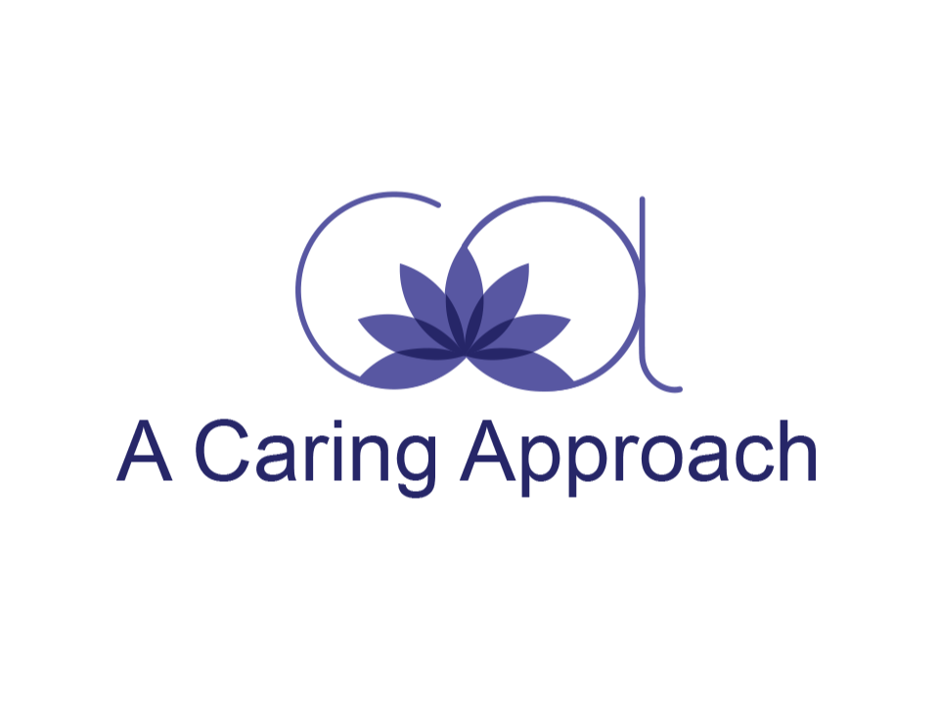
Tele therapy refers to providing remote therapeutic health services, using telecommunications technologies, such as video conferencing, for example, Doxy or Zoom, or telephone. One of the benefits of tele sessions is that the clinician and client can engage in services without being in the same physical location. This can be helpful in ensuring continuity of care if the clinician or client takes an extended vacation, moves to a different location, or is otherwise unable to continue to meet in person. It is a pleasing option during the current pandemic situation, where your comfort is most important. It is also more convenient and takes less time. Teletherapy, however, requires technical competence on both our parts to be helpful. Although there are benefits of tele sessions, there are some differences between telepsychology and psychotherapy in person, as well as some risks. For example:
Confidentiality and Risks to Confidentiality
I have a legal and ethical responsibility to make my best efforts to protect all communications that are a part of our tele session. With the nature of electronic communications technologies being as such, I cannot guarantee that our communications will be kept confidential or that other people may not gain access to our communications. I will try to keep your information private but know there is a risk that our electronic communications may be unsecured, compromised, or accessed by others. You should also take reasonable steps to ensure the security of our communications (for example, only using secure networks for tele sessions and having passwords to protect the device you use for sessions).
Because tele sessions take place outside of the therapist’s private office, there is potential for other people to overhear sessions if you are not in a private place during the session. On my end I will take reasonable steps to ensure your privacy. But it is important for you to make sure you find a private place for our session where you will not be interrupted. It is also important for you to protect the privacy of our session on your cell phone or other device. You should participate in a session only while in a room or area where other people are not present and cannot overhear the conversation. It would be helpful if you could use headphones or earbuds, as they would limit the distractions from outside conversations.
The extent of confidentiality and the exceptions to confidentiality that I outlined in my Informed Consent still apply in tele sessions. Please let me know if you have any questions about exceptions to confidentiality, and I will be happy to discuss them with you.
Issues Related to Technology
There are many ways that technology issues might impact tele session. For example, technological devices may stop working during a session, or stored data could be accessed by unauthorized people or companies
Crisis Management and Intervention
Usually, I will not engage in tele sessions with clients who are currently in a crisis, where there is a need for high levels of support and intervention. Before engaging in tele sessions, we will develop an emergency response plan to address potential crisis situations that may arise during our tele work. This is for your safety.
If the session is interrupted and you are not having an emergency, disconnect from the session and I will wait a couple of minutes and then re-contact you via the tele platform on which we agreed to conduct therapy. If you do not receive a call back within a couple of minutes, then call me on the phone number I provided you (703-408-4965).
For communication between sessions, I only use email communication and text messaging with your permission and only for administrative purposes unless we have made another agreement. This means that text messages and email exchanges with my office should be limited to administrative matters. This includes things like setting and changing appointments, billing issues, and other related issues. You should be aware that I cannot guarantee the confidentiality of any information communicated by text or email. Therefore, I will not discuss any clinical information by text or email and ask that you do not either. While my email and text are my own and not accessed by anyone else, it is still important that you do not send confidential information via these means. Also, these methods should not be used in the event of an emergency.
Appropriateness of Telepsychology
At times we may schedule office in-person sessions to “check-in” with one another. I will let you know if I decide that teletherapy is not the most appropriate form of treatment for you. We will discuss options of engaging in in-person counseling or referrals to another professional in your location who can provide appropriate services. Again, your comfort level is most important. If we decide that in-person sessions are the best course of treatment, all precautions will be taken to ensure both of our safety.

We will decide together which kind of tele session service to use. You may have to have certain computer or cell phone systems to use tele session services. You are solely responsible for any cost to you to obtain any necessary equipment, accessories, or software necessary to take part in a tele session.
Efficacy
Most research shows that telepsychology is about as effective as in-person psychotherapy. However, some therapists believe that something is lost by not being in the same room. For example, there is debate about a therapist’s ability to fully understand non-verbal information when working remotely, I have found teletherapy to be extremely effective. I will do my best to ensure that I understand and communicate clearly and thoroughly as possible. If the session is interrupted for any reason, such as the technological connection fails, and you are having an emergency, do not call me back; instead, call 911, or go to your nearest emergency room. Call me back after you have called or obtained emergency services.
Fees
The same fee rates will apply for tele sessions as apply for in-person psychotherapy. Some insurance companies may not cover sessions that are conducted via telecommunication. As I stated in our initial conversations, I do not take insurance payments. If your insurance provider does not cover electronic psychotherapy sessions, you will be solely responsible for the entire fee of the session. No reimbursement will be made to you if tele sessions are not covered by insurance. It will be your responsibility to contact your insurance company prior to our engaging in telepsychology sessions to determine your coverage. If there is a technological failure and we are unable to resume the connection, you will only be charged the prorated amount of actual session time.
Records
The telepsychology sessions shall not be recorded in any way unless agreed to in writing by mutual consent. A record of our tele session will be kept in the same way I maintain records of in-person sessions in accordance with my policies.
Informed Consent
This agreement is intended as a supplement to the informed consent form that we agreed to at the outset of our clinical work together and does not amend any of the terms of that agreement. Your signature below indicates agreement with its terms and conditions.

_______________________________ ______________________
Client Date

_______________________________ ______________________
Therapist Date

