Carlos Durana, Ph.D., M.Ac.
4915 St. Elmo Ave., Suite 504 - Room 7C  Bethesda, MD 20814  301-654-0800 | 2265 Cedar Cove Court  Reston, VA 20191  703-408-4965  703-620-0420 (FAX)
COACHING AGREEMENT
This agreement is made between Carlos Durana (“COACH”) and _________________________ (“CLIENT”). Please read this carefully and indicate your agreement by signing at the bottom of the page. Let me know if you have any questions or concerns.
Coaching Guidelines and Commitment
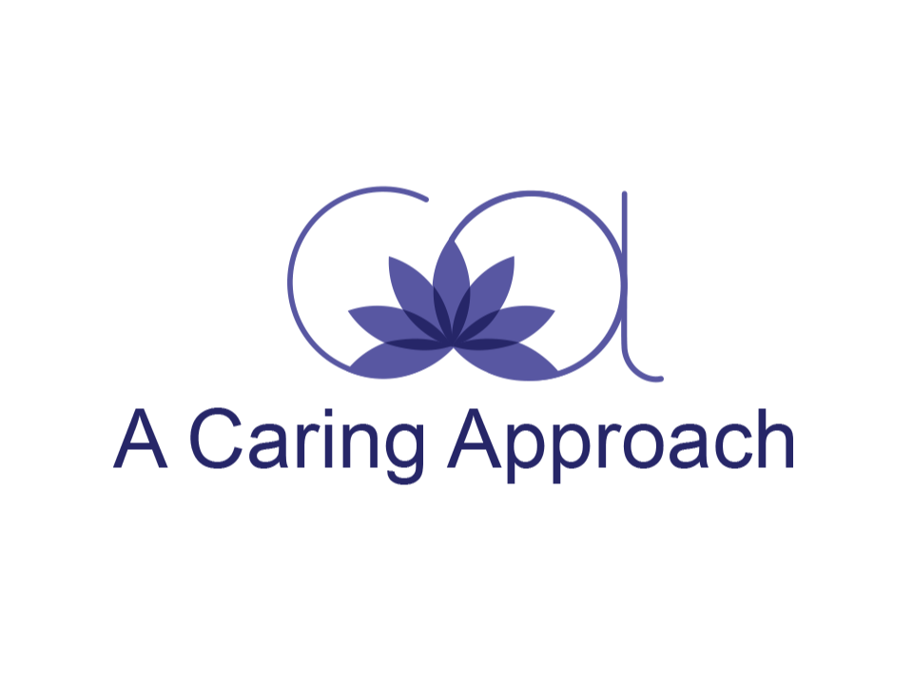
Coach has positive expectations for a coaching relationship that helps Client create the life he/she wants to live. The opportunity for Client’s success increases considerably because of Client’s and Coach’s relationship and the commitment involved from the two.
Coaching is a structure that facilitates the process of personal and professional development. Coaching may address life balance and quality of life, health and wellbeing, personal projects or job performance satisfaction. Client and Coach agree that the coaching relationship will be designed together.
Coaching is for persons who are psychologically healthy and who want to make changes to empower themselves. Coaching is not counseling or therapy.
Client and Coach acknowledge that Client wants to make progress and change in his/her life. Coaching is a process. Many people create change for themselves in a short time. However, to refine and sustain change takes several months. Progress and change are specific to each individual. Although not binding, Client and Coach commit to working together for an initial three-month period. This allows the necessary time to develop objectives and progress through obstacles and successes. If the coaching is not working as Client wishes, Client should inform Coach immediately so that steps can be taken to correct any problems.
Coaching Session Guidelines
Coaching sessions are conducted in person or by telephone, unless otherwise arranged. After the initial three-month period, coaching sessions are arranged as needed. Sessions are started and concluded on time. If Client is late for a session, the time will not be extended after the allocated time. Fees are paid at the time of the appointment. For telephone sessions, Client will pay for telephone charges. To reschedule a session, please allow at least 24 hours’ notice, or the session fee will be charged. Coach wants to have a coaching relationship that is honest, direct, open and trusting. Telephone or email communication may pose extra challenges since we cannot see facial expressions, body language, etc. Therefore, Client and Coach each agree to promptly ask for clarification if there is a misunderstanding and we are using either of these methods of communication.
In between coaching sessions, Client may feel free to email or call Coach. Calls made between the scheduled calls are permissible. Coach will conduct calls of five minutes or less free of charge, but Client will be charged accordingly for longer calls. There is no commitment beyond month to month, but Client is asked to give Coach a week’s notice if he/she thinks he/she will be ending our Coaching together.
Confidentiality
The coaching relationship is built on trust. Coach agrees to keep all information and conversations with Client private and confidential. No personal information expressed by Client will be shared with anyone except with the written permission of Client or by a court order. Confidentiality is followed to the fullest extent of the law and so long as Coach does not fear for Client’s or another’s safety.
Coach Agreement
Coach cannot guarantee results. Client’s intentions, choices, courage and determination to take actions in his/her life will create the results Client desires.
Coach will fully collaborate with Client to identify and achieve Client’s personal and professional goals. If issues come up for Client that should be handled by a physician, therapist or other health professional, Coach will recommend that Client attend to his/her health by contacting the appropriate professional.
Coach will bring support, understanding, and a belief in Client and Client’s commitment to his/her own success. Part of Coach’s job is to challenge Client, offer different perspectives, make suggestions (including assigning homework) and acknowledge Client’s successes.
Client Agreement
Client is committed and motivated to take action on his/her personal and professional goals. Client acknowledges that only his/her intentional full participation will lead to success. Client realizes that the process of change can involve feelings of discomfort and frustration.
Client accepts full responsibility for himself/herself and the actions he/she takes that might result from coaching. Client acknowledges that he/she is healthy enough to engage in coaching.

Client has read the Coaching Agreement and agrees with its terms.
Signature: ____________________________________________________________
Name: ____________________________________________________________
Address: ____________________________________________________________
Telephone: ____________________________________________________________
Email: ____________________________________________________________
Date: ____________________________________________________________

Coach has read the Coaching Agreement and agrees with its terms.

Signature: ____________________________________________________________
Date: ____________________________________________________________

[This space was intentionally left blank.]

