Carlos Durana, Ph.D., M.Ac.
4915 St. Elmo Ave., Suite 504 - Room 7C  Bethesda, MD 20814  301-654-0800 | 2265 Cedar Cove Court  Reston, VA 20191  703-408-4965  703-620-0420 (FAX)
ASSESSING OUR RELATIONSHIP QUESTIONNAIRE:
LOOKING BACK: OUR EARLY RELATIONSHIP
How did you meet? What were your first impressions?
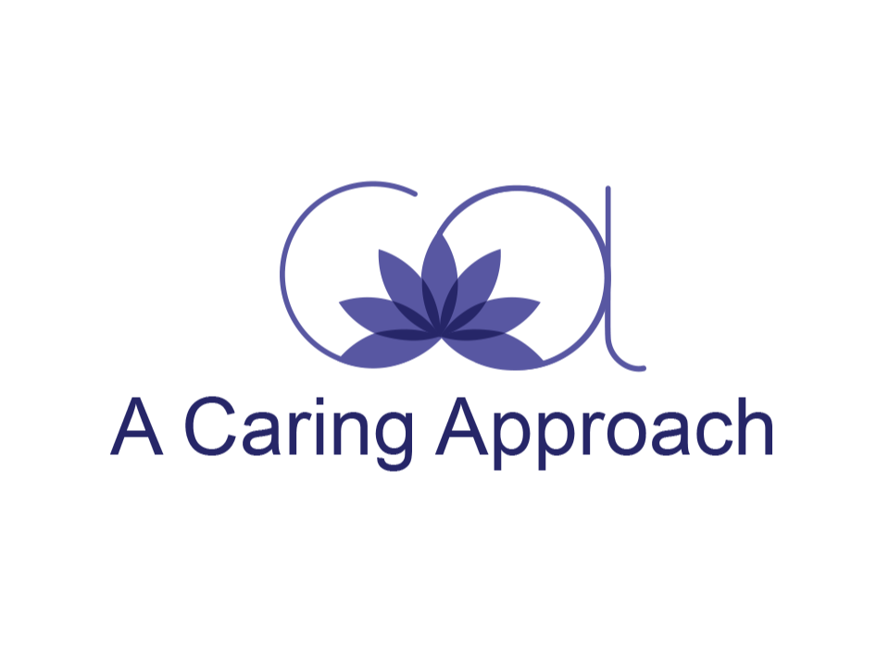
What attracted you to your partner? What did you like and fall in love with? Why did you choose your partner? What qualities attracted you that would make you more attracted to your partner now?
How did you express your fondness, admiration, respect, appreciation, and liking for your partner during the first few months (to a year) of your relationship? How did he/she express these feelings towards you?
How did you decide to get married? What were the joys and difficulties surrounding the event?
Describe your honeymoon.
What was the vision of the relationship you wanted when you first met?
Describe the happy times in your relationship.
Describe major transitions in your relationship (parenting, career moves, extended family, etc.) Discuss the ups and downs.
What kind of pleasurable things did you do at the beginning of the relationship? Which ones do you still do?
How have you managed to stay together?
What have been the greatest assets in your relationship? The greatest limitations?
What do you like best about yourself? Least?
What do you like best about your partner? Least?

Offering Couples Counseling, Couples Therapy, Marriage Counseling, and Marriage Therapy in Reston, VA. and Bethesda, MD.

