Carlos Durana, Ph.D., M.Ac.
4915 St. Elmo Ave., Suite 504 - Room 7C  Bethesda, MD 20814  301-654-0800 | 2265 Cedar Cove Court  Reston, VA 20191  703-408-4965  703-620-0420 (FAX)
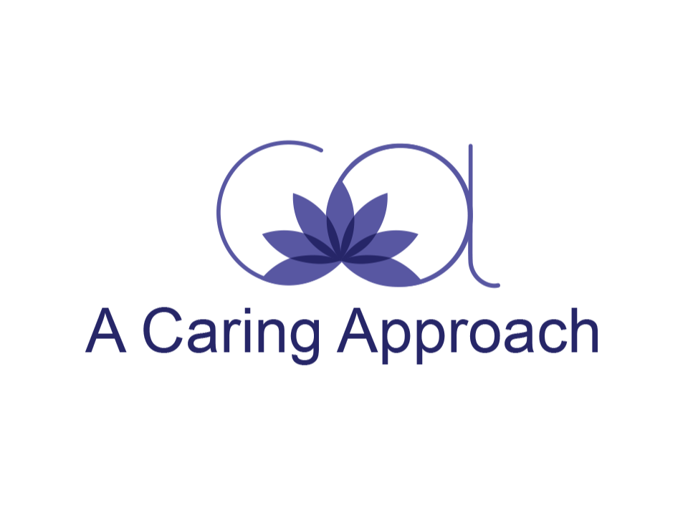
ADOLESCENT INFORMED CONSENT FORM
What to expect:
The purpose of meeting with a counselor or therapist is to get help with problems in your life that are bothering you or that are keeping you from being successful in important areas of your life. You may be here because you wanted to talk to a counselor or therapist about these problems. Or, you may be here because your parent, guardian, doctor or teacher had concerns about you. When we meet, we will discuss these problems. I will ask questions, listen to you and suggest a plan for improving these problems. It is important that you feel comfortable talking to me about the issues that are bothering you. Sometimes these issues will include things you don’t want your parents or guardians to know about. For most people, knowing that what they say will be kept private helps them feel more comfortable and have more trust in their counselor or therapist. Privacy, also called confidentiality, is an important and necessary part of good counseling.
As a general rule, I will keep the information you share with me in our sessions confidential, unless I have your written consent to disclose certain information. There are, however, important exceptions to this rule that are important for you to understand before you share personal information with me in a therapy session. In some situations, I am required by law or by the guidelines of my profession to disclose information whether or not I have your permission. I have listed these situations below.
Confidentiality cannot be maintained when:
You tell me you plan to cause serious harm or death to yourself, and I believe you have the intent and ability to carry out a threat in the very near future. I must take steps to inform a parent or guardian of what you have told me and how serious I believe this threat to be. I must make sure that you are protected from harming yourself.
You tell me you plan to cause serious harm or death to someone else who can be identified, and I believe you have the intent and ability to carry out this threat in the very near future. In this situation, I must inform your parent or guardian, and I must inform the person who you intend to harm.
You are doing things that could cause serious harm to you or someone else, even if you do not intend to harm yourself or another person. In these situations, I will need to use my professional judgment to decide whether a parent or guardian should be informed.
You tell me you are being abused-physically, sexually or emotionally – or that you have been abused in the past. In this situation, I am required by law to report the abuse to the Department of Social Services.
You are involved in a court case and a request is made for information about your counseling or therapy. If this happens, I will not disclose information without your written agreement unless the court requires me to. I will do all I can within the law to protect your confidentiality, and if I am required to disclose information to the court, I will inform you that this is happening.
Communicating with your parent(s) or guardian(s):
Except for situations such as those mentioned above, I will not tell your parent or guardian specific things you share with me in our private therapy sessions. This includes activities and behavior that your parent or guardian would not approve of – or would be upset by – but that do not put you at risk of serious and immediate harm. However, if your risk-taking behavior becomes more serious, then I will need to use my professional judgment to decide whether you are in serious and immediate danger of being harmed. If I feel that you are in such danger, I will communicate this information to your parent or guardian.
Example: If you tell me that you tried alcohol at a few parties, I would keep this information confidential. If you tell me that you are drinking and driving or that you are a passenger in a car with a driver who is drunk, I would not keep this information confidential from your parent or guardian. If you tell me, or if I believe based on things you’ve told me, that you are addicted to alcohol, I would not keep this information confidential.
Example: if you tell me that you are having protected sex with a boyfriend or girlfriend, I would keep this information confidential. If you tell me that, on several occasions, you have engaged in unprotected sex with people you do not know or in unsafe situations, I will not keep this information confidential. You can always ask me questions about the types of information I would disclose. You can ask in the form of “hypothetical questions,” in other words: “if someone told you that they were doing _______, would you tell their parents?”
Even if I have agreed to keep information confidential – to not tell your parent or guardian – I may believe that it is important for them to know what is going on in your life. In these situations, I will encourage you to tell your parent or guardian and I will help you find the best way to tell them. Also, when meeting with your parent or guardian, I may sometimes describe problems in general terms, without using specifics, in order to help them know how to be more helpful to you.
[You should also know that, by law in Virginia, your parent or guardian has the right to see any written records I keep about our sessions. It is extremely rare that a parent or guardian would ever request to look at these records.]
Communicating with other adults:
School: I will not share any information with your school unless I have your permission and permission from your parent or guardian. Sometimes I may request to speak to someone at your school to find out how things are going for you. Also, it may be helpful in some situations for me to give suggestions to your teacher or counselor at school. If I want to contact your school, or if someone at your school wants to contact me, I will discuss it with you and ask for your written permission. A very unlikely situation might come up in which I do not have your permission but both I and your parent or guardian believe that it is very important for me to be able to share certain information with someone at your school. In this situation, I will use my professional judgment to decide whether to share any information.
Doctors: Sometimes your doctor and I may need to work together; for example, if you need to take medication in addition to seeing a counselor or therapist. I will get your written permission and permission from your parent or guardian in advance to share information with your doctor. The only time I will share information with your doctor even if I don’t have your permission is if you are doing something that puts you at risk for serious and immediate physical/medical harm.

Adolescent therapy client:
Signing below indicates that you have reviewed the policies described above and understand the limits to confidentiality. If you have any questions as we progress with therapy, you can ask your therapist at any time.

Minor’s signature__________________________________ Date_________

***
Parent/Guardian:
Check boxes and sign below indicating your agreement to respect your adolescent’s privacy:
/_/ I will refrain from requesting detailed information about individual therapy sessions with my child. I understand that I will be provided with periodic updates about general progress, and/or may be asked to participate in therapy sessions as needed.
/_/ Although I have the legal right to request written records/session notes since my child is a minor, I agree NOT to request these periodic records in order to respect the confidentiality of my adolescent’s treatment.
/_/ I understand that I will be informed about situations that could endanger my child. I know this decision to breach confidentiality in these circumstances is up to the therapist’s professional judgment and may sometimes be made in confidential consultation with her consultant/supervisor.

Parent/Guardian signature: ____________________________________ Date: __________
Parent/Guardian signature: _____________________________________Date: __________
Parent/Guardian signature: _____________________________________Date: __________

